**Octopus Deploy:**

1. Download and Install Sql server & Octopus Deploy
2. After Full installation press Add Environment Variable like ‘Production’
3. Add Deployment Target ‘Listening tentacle’
4. In Create Listening tentacle page download the tentacle file and install the octopus server
5. When installing the tentacle you need the Octopus thumbprint. Go to octopus server where you are in create listening tentacle page you find the thumbprint copy it and paste into tentacle installer.
6. Now go to create listening tentacle page and enter hostname(production server IP address) and port
7. Skip adding external feed (In Application Packaging add external feeds(feed url will be TeamCity server URL)) It will be upload package from TeamCity (Automatically).
8. In Project create page add a project name. After that add deployment process.
   1. Step name
   2. On Target in role
   3. Package Details package ID Will Be TeamCity Project Name
   4. Click configure feature under Package details and check the custom install directory. Add custom install directory like ‘C:\OctopusPublish\TRMS’.
9. Now go to Create release project and create a release and deploy.

**TeamCity:**

1. Download and Install the TeamCity
2. Create an Access token into TFS server
3. Connect Source control into TeamCity to TFS Server with Token
4. Select a project from Source control in TeamCity
5. Download & install the .Net SDK from here (<https://www.microsoft.com/net/learn/dotnet/hello-world-tutorial>)
6. Download MS Build tool and install from here (<https://www.microsoft.com/en-us/download/details.aspx?id=40760>) for MS Build 2013 OR (<https://www.microsoft.com/en-us/download/details.aspx?id=48159>) for MS Build 2015
7. Download Octopus plugin from here ( <https://plugins.jetbrains.com/plugin/9038-octopus-deploy>) and go to administration>plugin list > upload plugin > Select octopus plugin that download few moment ago.
8. After upload Restart the TeamCity server from Windows service
9. Copy the Microsoft folder to “C:\Program Files\dotnet\sdk\2.1.403” AND “C:\Program Files (x86)\MSBuild” (if visual studio does not installed)
10. Go to Build Configuration setting > General setting and it will be like:

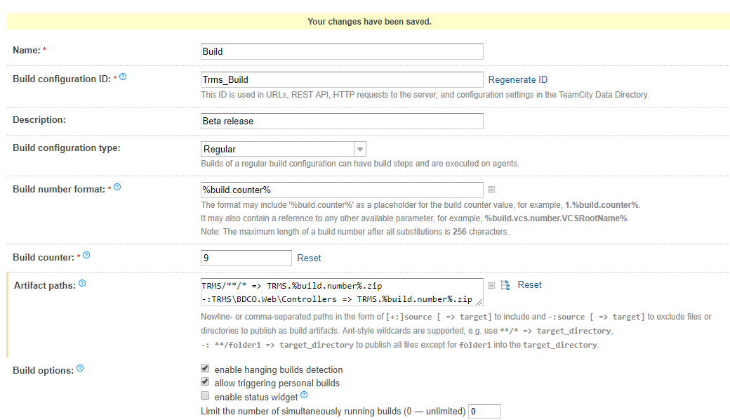

1. Now go to Build Configuration setting > Build steps. Build steps will be like

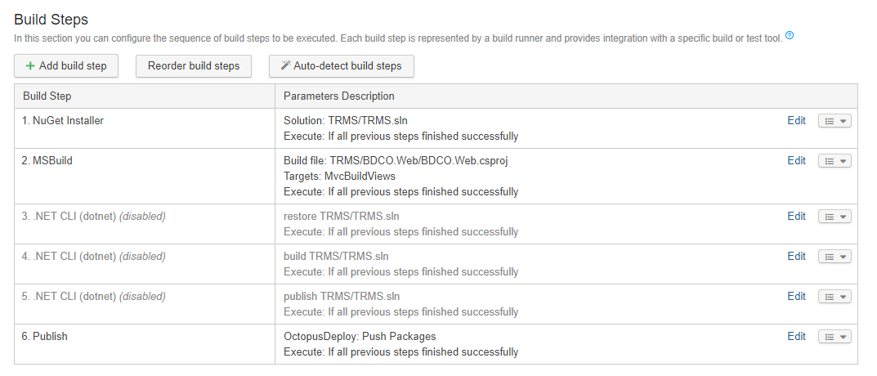

1. NuGet Installer it will be like:

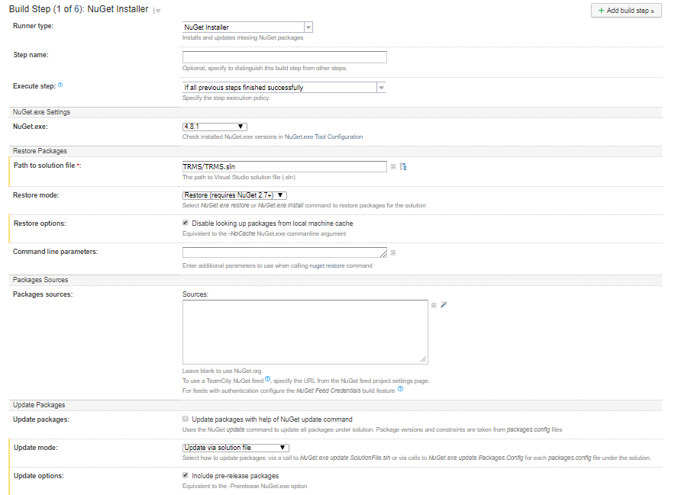

1. MS Build will be like: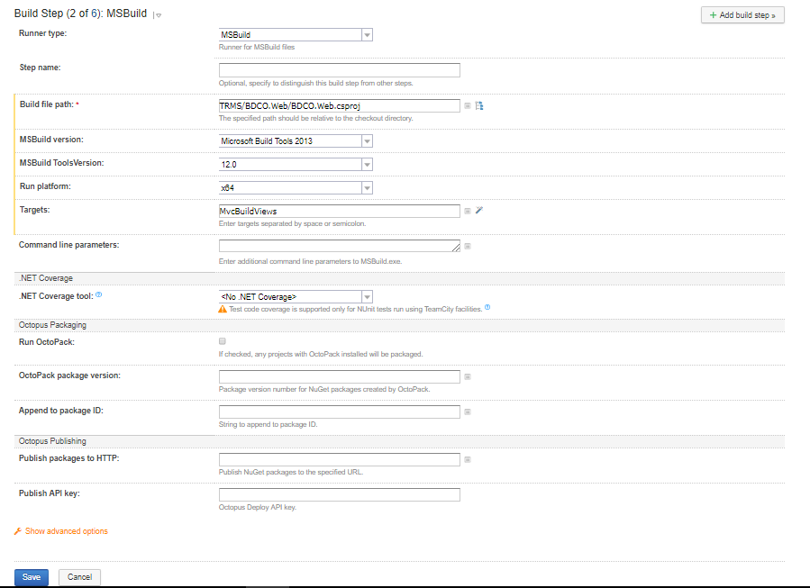
2. Disable it (you can also delete it)
3. Disable it (you can also delete it)
4. Disable it (you can also delete it)
5. PublishGo to build steps and add new step like below.  
   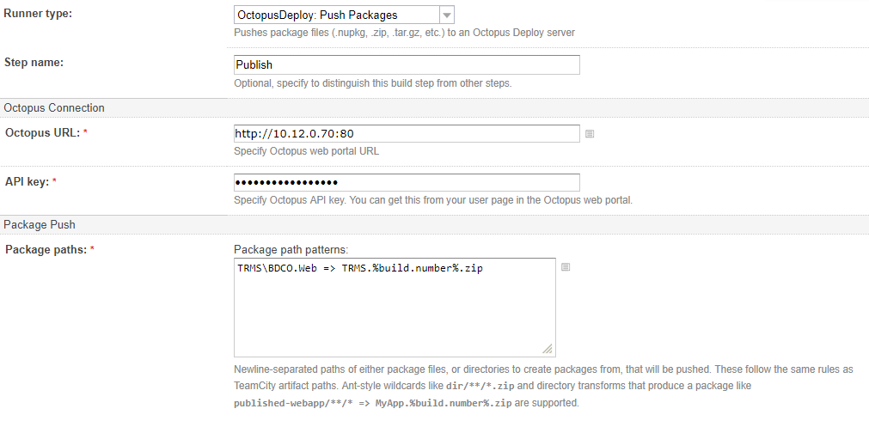
6. Now in TeamCity project select project go to build and then Click run